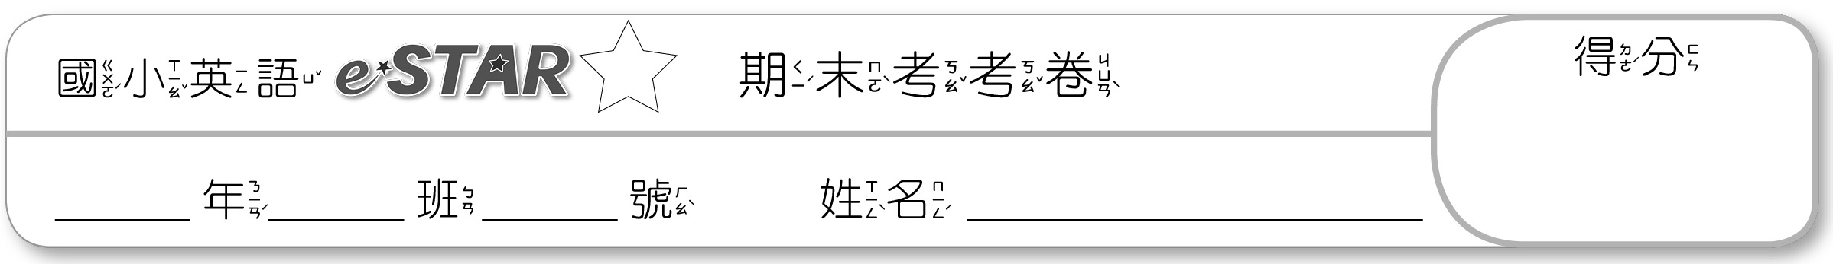
A卷
2

一、Listen and Choose 仔細聽，選出正確的
生字：(每題3分，共15分)
1. ( ) 2. ( )
① a student ① a farmer
② a doctor ② father
③ sister ③ brother
Track 01 1. Ans: a student 2. Ans: a farmer
3. ( ) 4. ( )
① a farmer ① a student
② mother ② sister
③ brother ③ a nurse
3. Ans: mother 4. Ans: a nurse
5. ( )
① brother
② sister
③ a farmer
5. Ans: brother
二、Listen and Mark 仔細聽發音，發音與發音字相符畫圈，不符畫叉：(每題2分，共12分)
1. ( ) hut 2. ( ) dug
Track 02 1. Ans: hop 2. Ans: dot
3. ( ) pot 4. ( ) hot
3. Ans: pot 4. Ans: hot
5. ( ) bad 6. ( ) net
5. Ans: bud 6. Ans: nut
三、Listen and Choose 仔細聽句子或對話，選出正確的圖片：(每題3分，共12分)
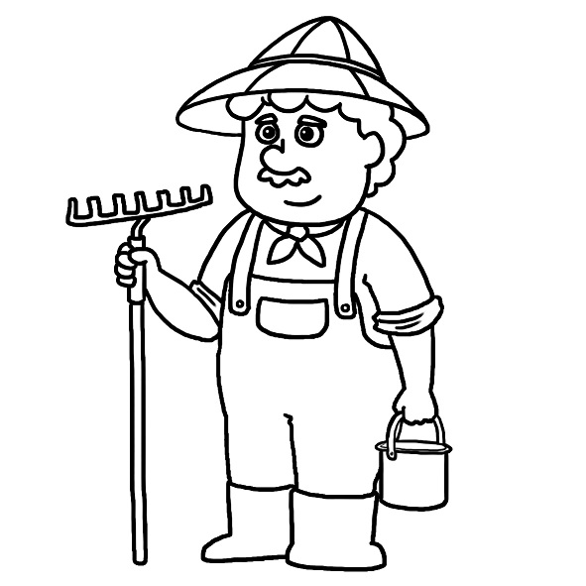
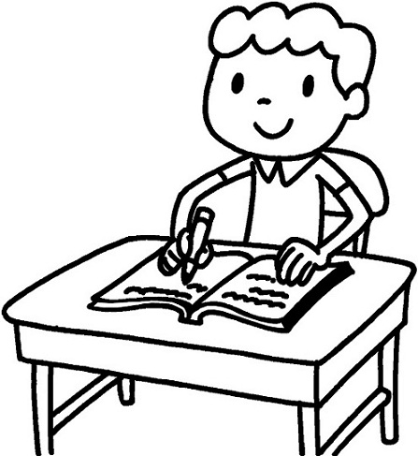

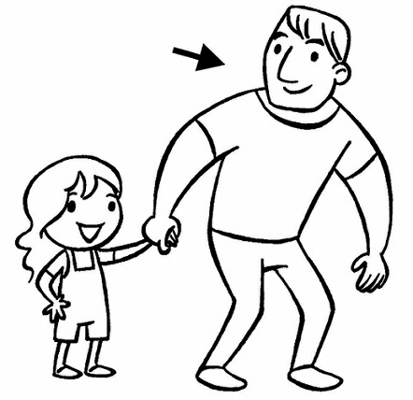
1. ( )
① ② ③ ④
Track 03 1. Ans: A: Is he a student? B: No, he isn’t. He’s a nurse.
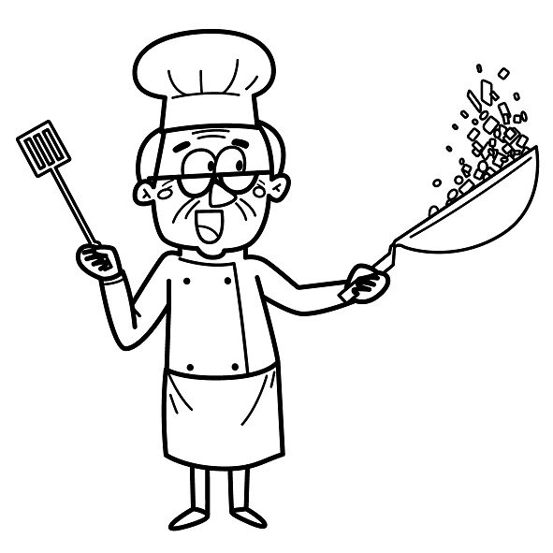


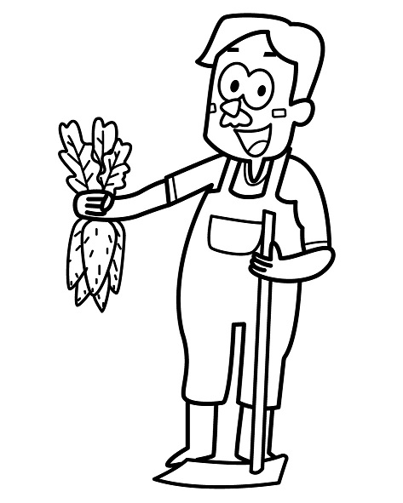
2. ( )
① ② ③ ④
2. Ans: A: Is he a doctor? B: No, he isn’t. He’s a farmer.
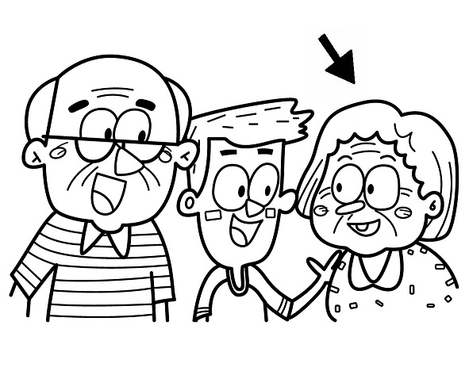
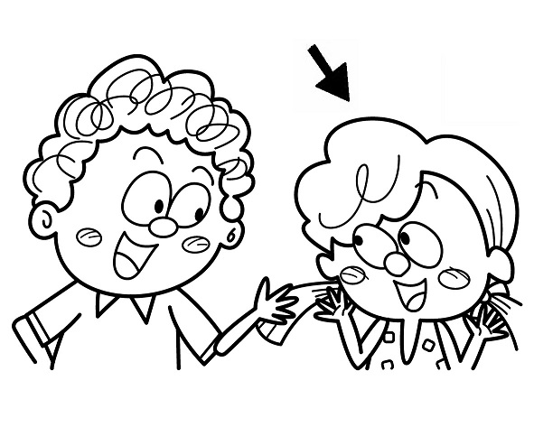
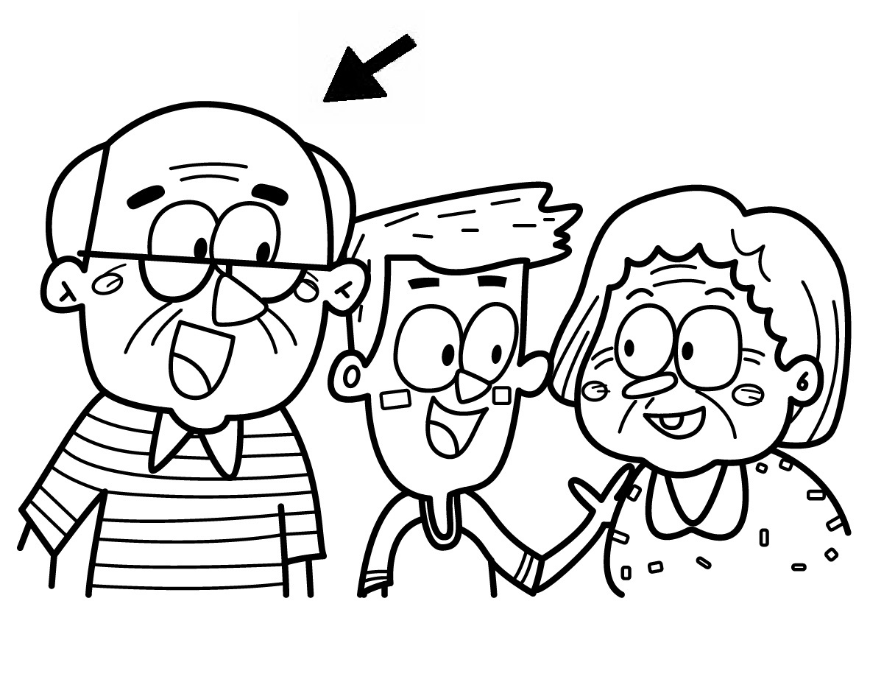
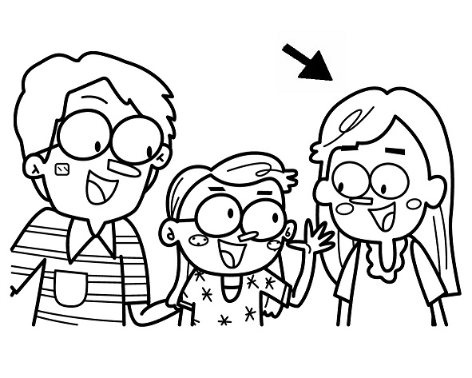
3. ( )
① ② ③ ④
3. Ans: A: Who’s she? B: She’s my grandmother.
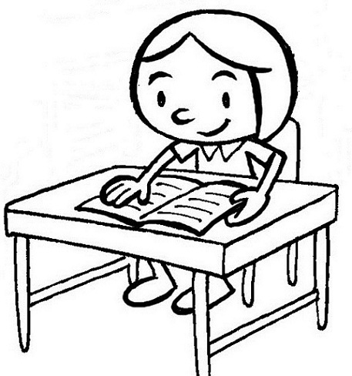
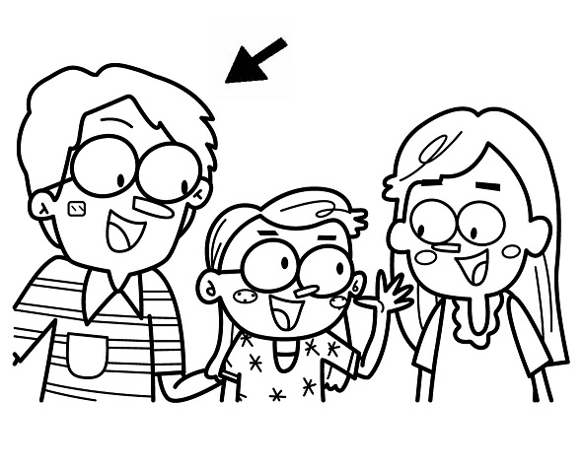
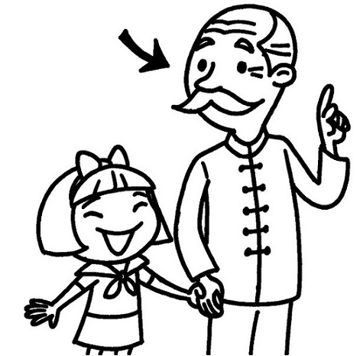
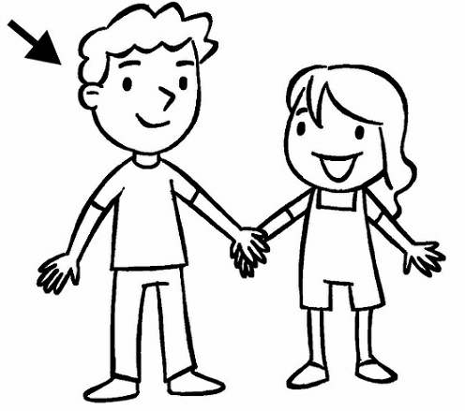
4. ( )
① ② ③ ④

4. Ans: A: Who’s he? B: He’s my brother.
四、Listen and Choose 仔細聽問句，選出最適當的答句：(每題3分，共12分)
1. ( )
① No, she isn’t.
She’s a student.
② No, she isn’t.
She’s a nurse.
③ She’s my mother.
Track 04 1. Ans: Is she a nurse?
2. ( )
① He’s my brother.
② Yes, she is.
③ She’s my sister.
2. Ans: Who’s she?
3. ( )
① She’s my mother.
② He’s my brother.
③ No, he isn’t.
3. Ans: Who’s he?

4. ( )
① She’s my mother.
② Yes, she is.
③ Yes, he is.
4. Ans: Is she a doctor?
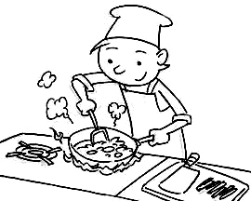
五、仔細看，將正確的生字圖打勾：(每題3分，共15分)
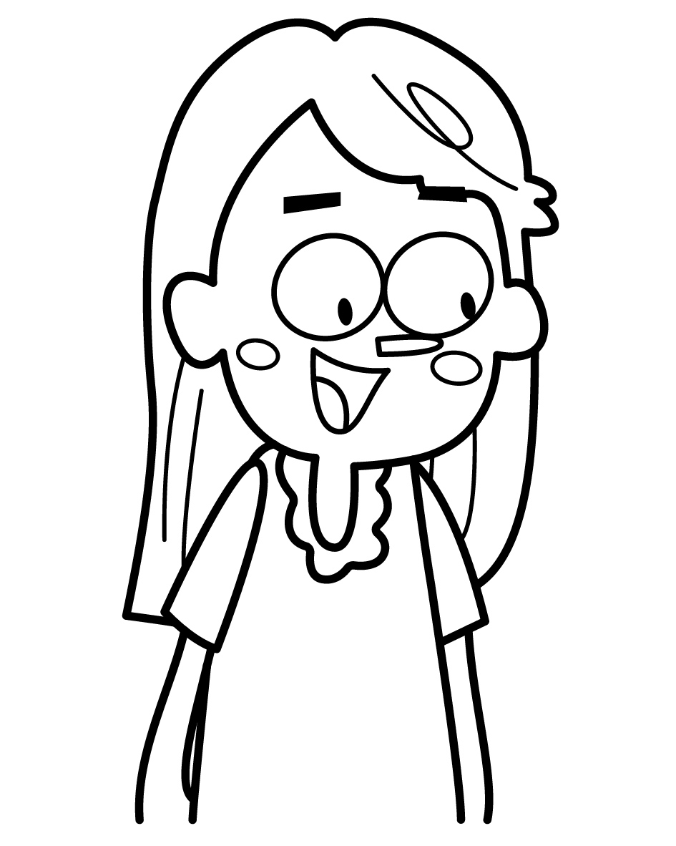
1. a cook □ □
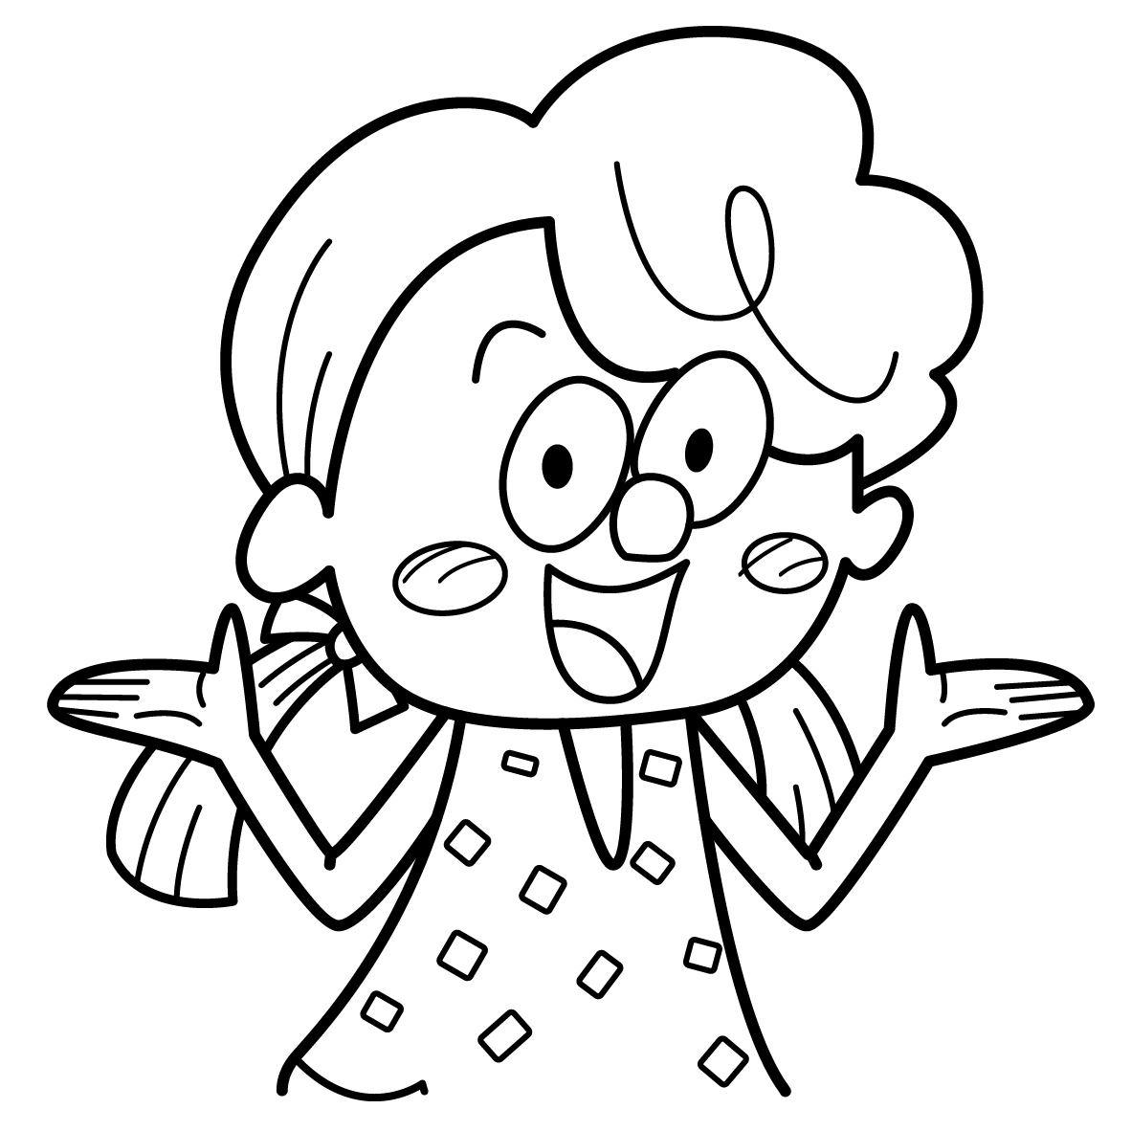
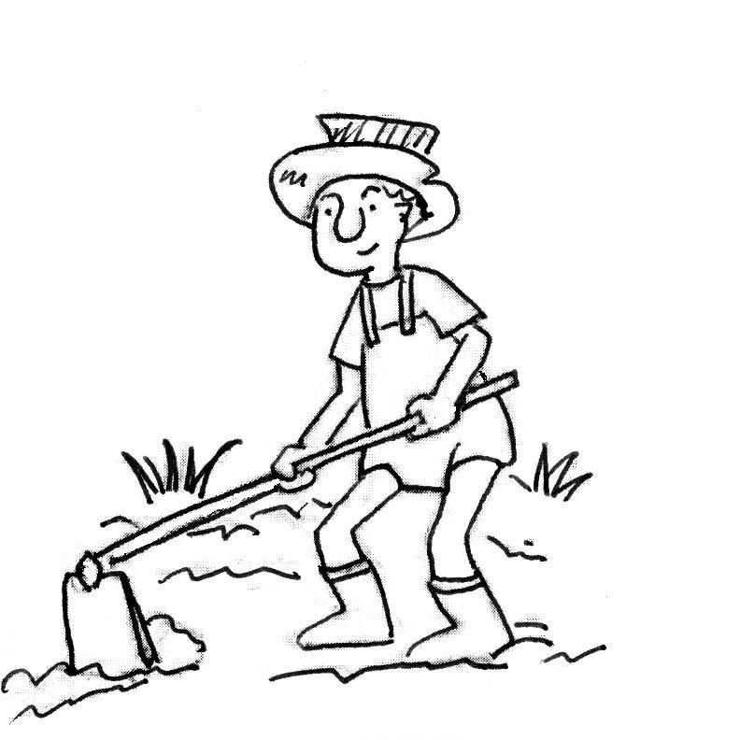
2. mother □ □

3. a farmer □ □
4. a doctor □ □

5. brother □ □
六、仔細看，選出正確的發音字：(每題2分，共10分)
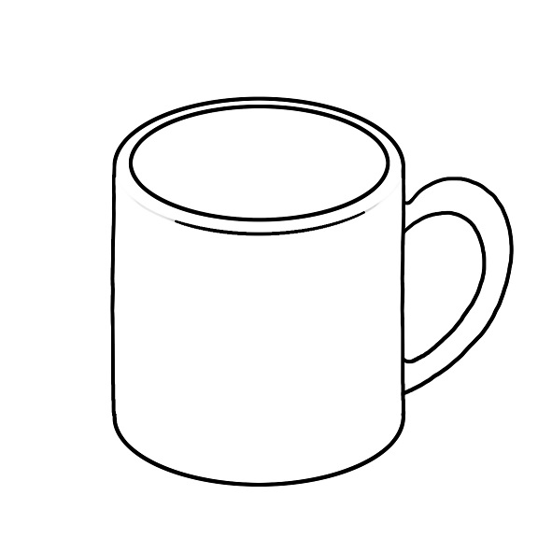

1. ( ) ① bug ② mug
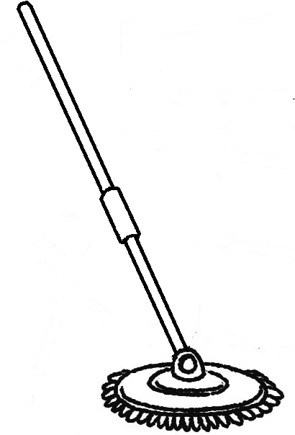
2. ( ) ① hut ② hat
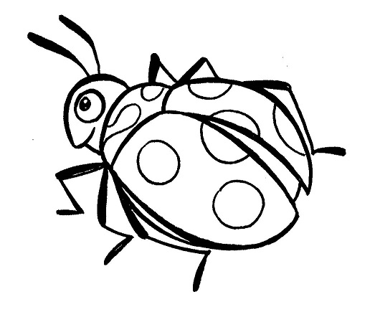
3. ( ) ① pot ② mop
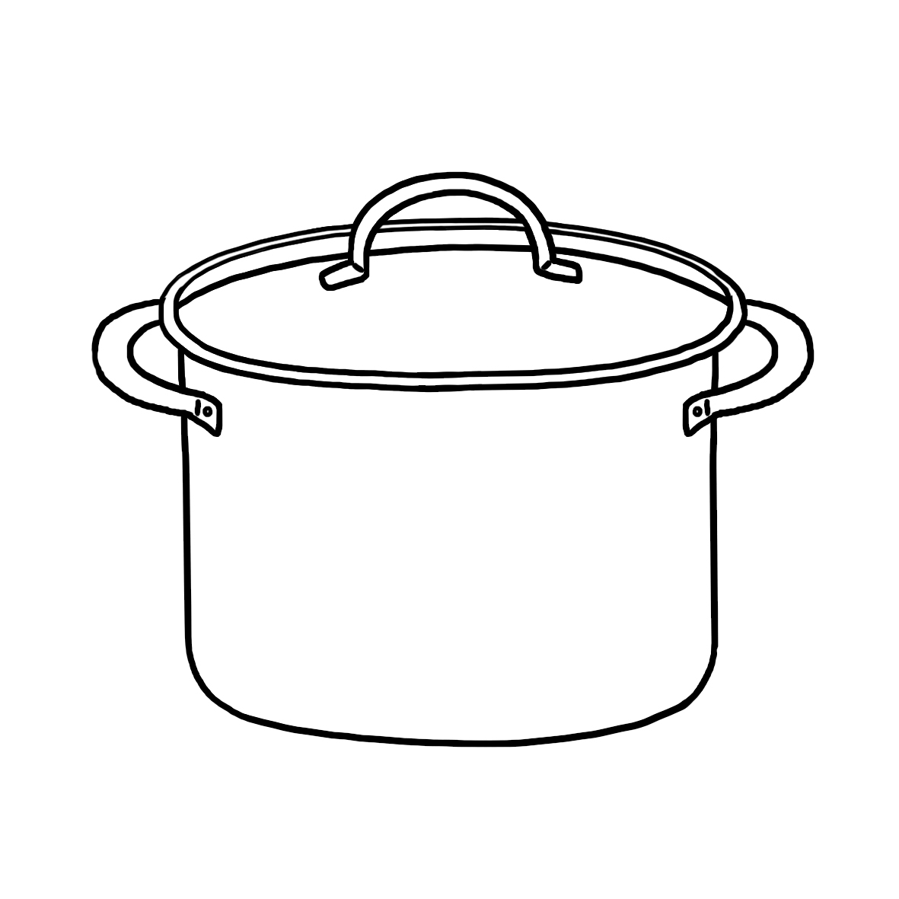
4. ( ) ① bag ② bug
5. ( ) ① pot ② top
七、讀一讀，句子與圖片相符合畫圈，不符合畫叉。：(每題3分，共12分)
1. ( ) She’s a student.

2. ( ) He’s my father.

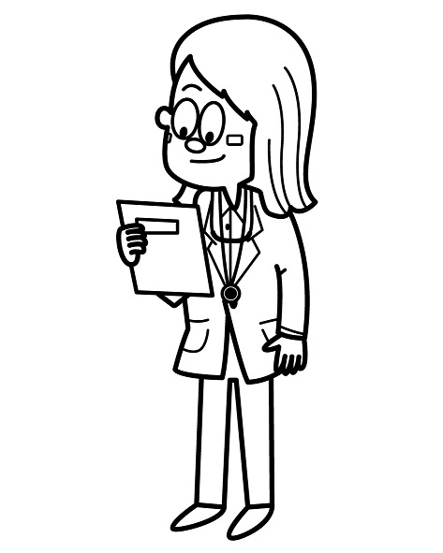
3. ( ) She’s a doctor.

4. ( ) She’s my grandmother.

八、仔細讀句子，選出最適當的答句或回應句：(每題3分，共12分)
1. ( )
Who’s he?
① He’s a twelve.
② He’s my brother.
③ He’s strong.
④ He’s a nurse.
2. ( )
Who’s she?
① She’s thin.
② She’s a student.
③ She’s my sister.
④ My mother is a cook.
3. ( )
Is your father a doctor?
① Yes, I am.
② Yes, it is.
③ No, he isn’t.
④ No, she isn’t.
4. ( )
Is your sister a student?
① Yes, he is.
He’s a student.
② No, she isn’t.
She’s a teacher.
③ No. She’s my sister.
④ She’s short.

